**Project Name : Designing Professional Business Card**

**1.Introduction**

**1.1 Overview**

Through this project we learn how to create Designing Professional Business Card by using Canva.

**1.2 Purpose**

The purpose of this project is to create a business card. And make ourself aware the new technological skills of now a days.

**2.Problem Definition & Design Thinking**

**2.1Empathy Map**

We have some trouble while gathering information on the Empathy Map.

Gathering a retable business information is quite different to us.

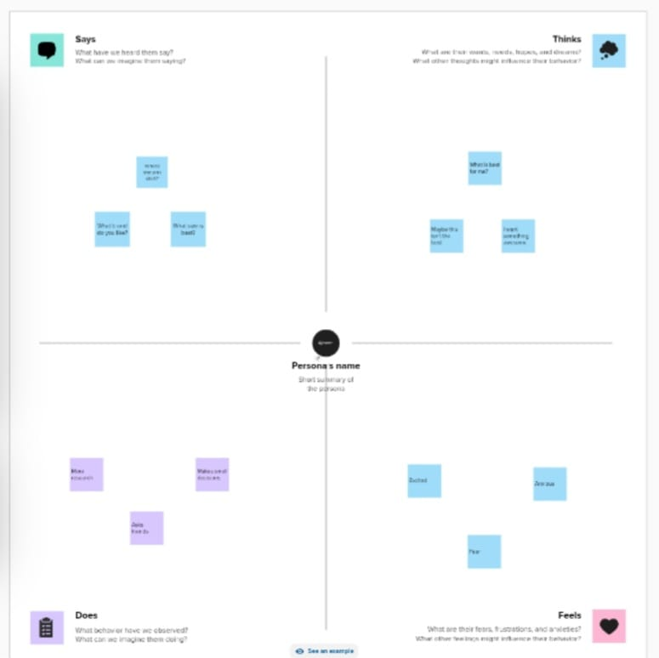

**2.2 Ideation & Brainstorming Map**

Discussing and getting same idea from the team members is little weird.

But through the team work we learn to know the unit of work.

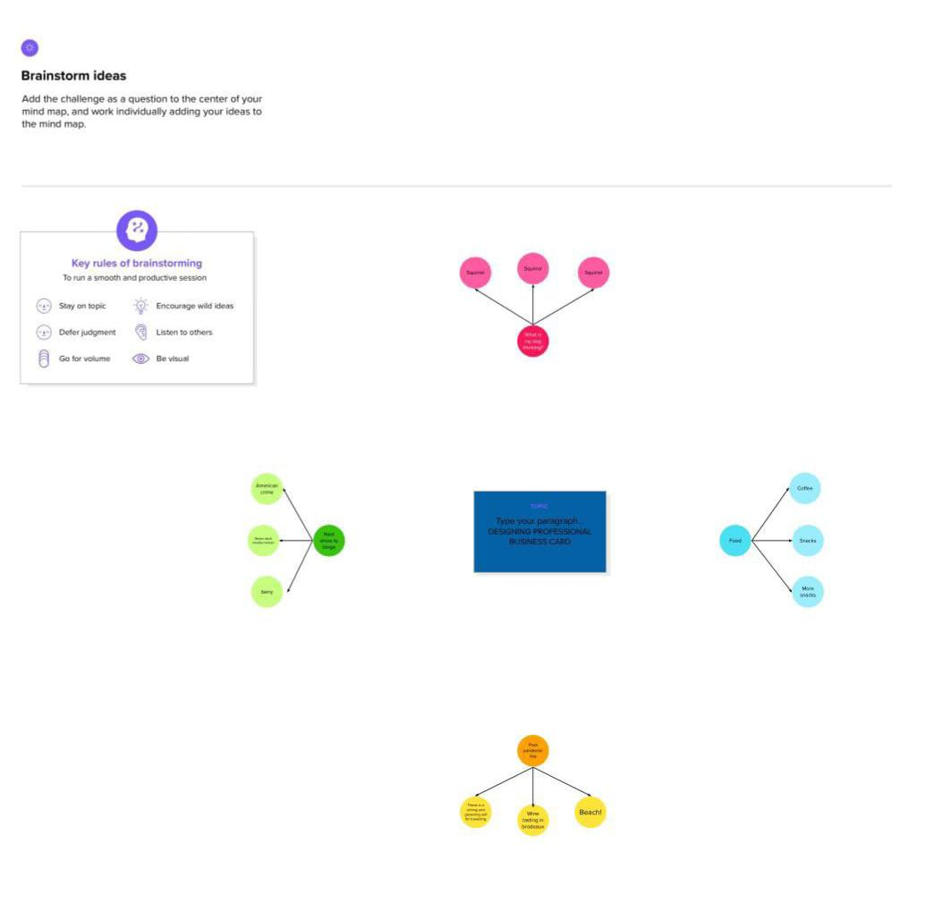

**3.Result**

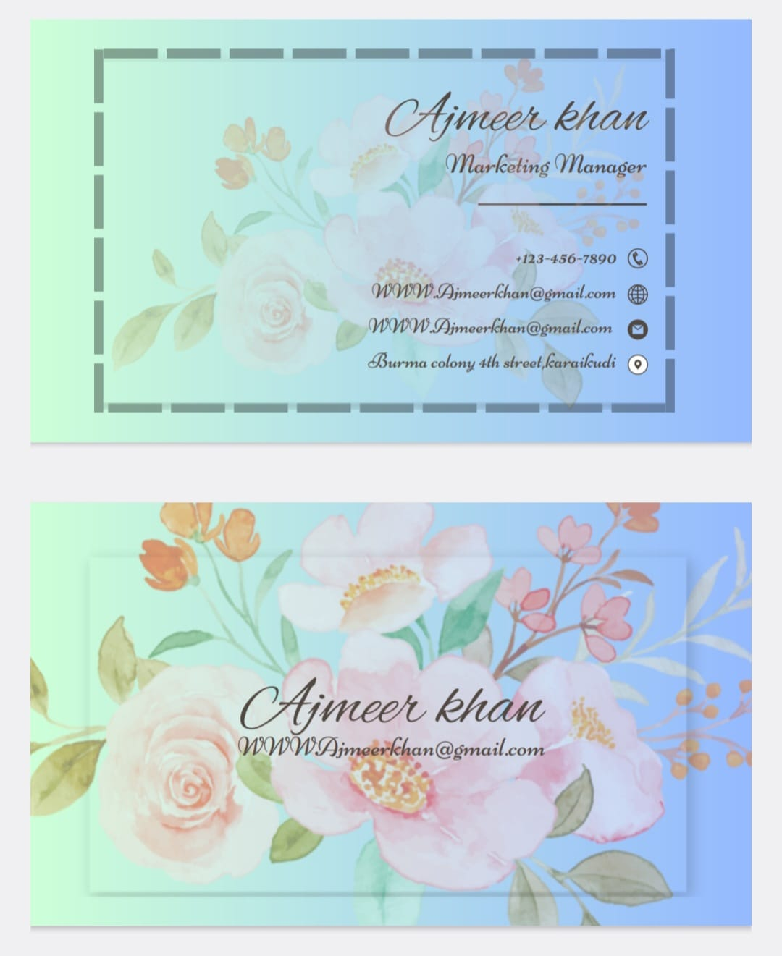

**4.Advantages & Disadvantages**

It is useful for us to learn the designing skill.

Designing is a very new field to us that’s the only disafvantage.

**5.Application**

We may apply the designing skill in future wherever is needed.

**6.Conclusion**

We learn a lot of new things about editing and how to make business card. It is really useful.